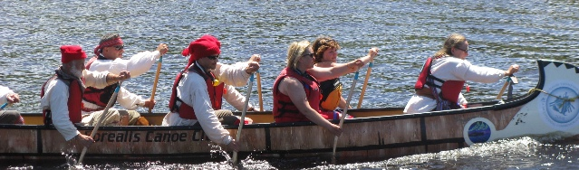
OpenAgile Foundations

Foundation Two: Consultative Decision-Making
"We never undertook to do any thing of any importance which was likely to affect each other, without mutual consultation. We were generally a unit, and moved together."

Consultative decision-making is a method for individuals, teams and organizations to take coherent action based on a unified vision. The process requires that all people involved in making a decision put themselves into a new frame of mind where truthfulness, humility and detachment are uppermost, rather than competition, debate and arguing. This means that after a decision is made, all those involved will fully support the decision, not just giving lip-service, but wholeheartedly acting in accord with the decision.
Rules of Consultative Decision-Making
Consultative decision-making is based on the following simple rules:
- Everyone is encouraged to contribute to the discussion; a diversity of views is welcomed
- No idea is owned by any individual and therefore it is okay to change your own mind
- Offence should never be given nor taken
- Personal attacks are absolutely forbidden; Aggressive interruption is considered bad behaviour
- Everyone should be able to fully express themselves in a frank, amicable, and courteous manner

Unified Action
Discussion ideally results in unanimous support for a line of action. However, if unanimity is not possible, a majority can carry a decision. In this case, though, once a decision is made, regardless of whether or not you voted for it, you fully support the decision. The reasoning is simple: by fully supporting the decision in unified action, whether or not the decision is correct, through reflection, a better way will become clear. Adjustments can then be made based on collectively learning about better approaches through experience.
Consultative decision-making can be used in all aspects of the OpenAgile process, it requires Truthfulness, and it is an essential component of OpenAgile.
Photo credit: Darin Zandee

